1: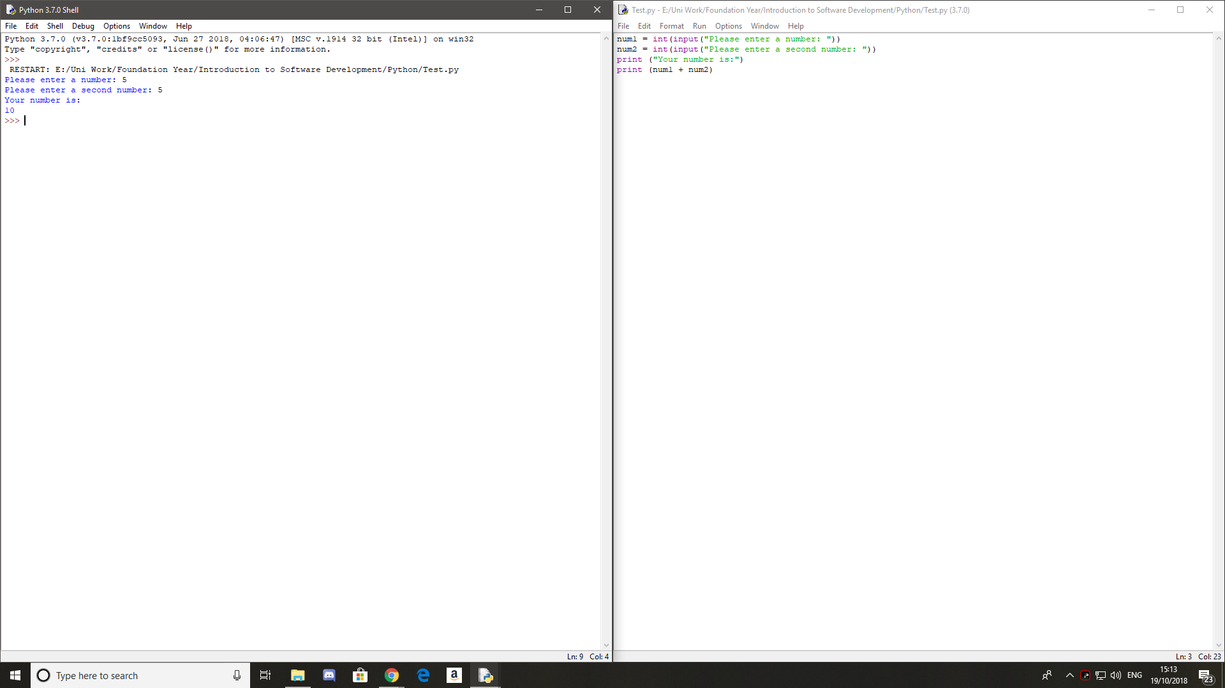

2:

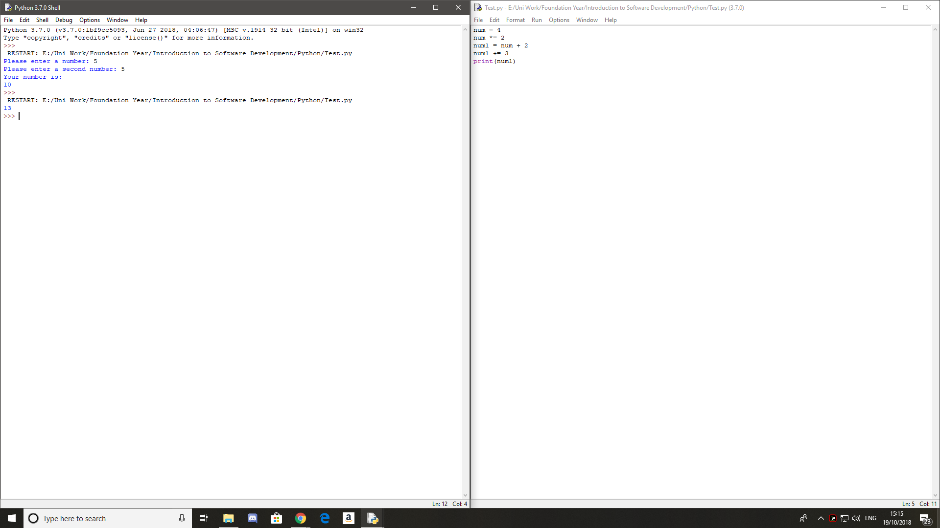

3:

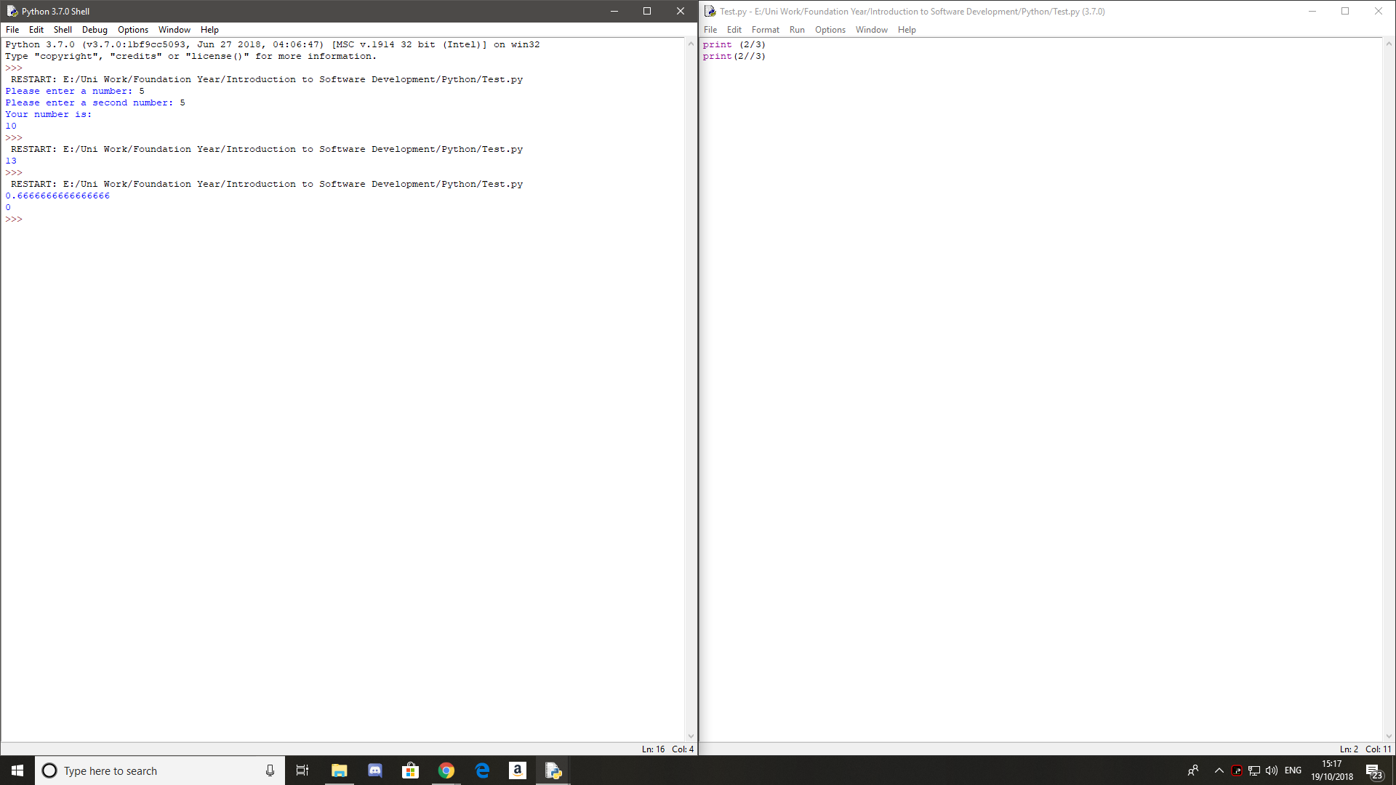

Print(2/3) returns a float hopwever print(2//3) removes the decimal point making it an int.

4:

All of the variable names below can be used. But which of these is the better variable name to use?

A a Area AREA area areaOfRectangle AreaOfRectangle

AreaOfRectangle

5:

Variable names not allowed in python:

1Apple

Account.number

5Return

Great.big.variable